MODELLING PROBLEM
ECO1010
University of Glasgow
16 March 2022

Problem 1
Some country is hit by sanctions that prohibit the import of modern technologies. As a result, all sectors of the economy are affected and have to resort to older and inferior production methods. (You may ignore any additional adverse effects of sanctions). To answer this question, consider two sectors: gas energy (controlled by a monopoly) and agriculture (competitive). Using economic models from our course, try to predict the changes in price and quantities traded and in consumer / producer surplus as well. Who bears the main burden of sanctions and why? Also consider the government policies that might mitigate the adverse effects, such as subsidies and taxation.

Modelling technology:
Imagine a situation where a very tech developed country has done something very wrong against humanity and a lot of very powerful countries want to punish him by using sanctions that prohibit the import of modern technologies. This action will lead the country to not be able to use these technologies or use them with a very high price. This country will have to be very self-sufficient and maybe if appropriate, change to older and inferior production methods.
We will assume that:
- Countries import goods that are more efficiently produced elsewhere
- Before the sanction, technology A is used. Suppose that this technology is innovative, modern, enterprising... had a lot of imported machines, goods. All of this created a high efficiency.
- After the sanction, tech B is used. This technology is older, inferior. The efficiency of this technology is lower. It’s clear that if we use inferior production methods, agriculture will drastically drop his productivity due to the high use of modern machinery that streamlines production.

The effect of sanctions depends on whether the good is produced locally or outside. In general, this change of technology may decrease higher production costs and make supplying a product less profitable, resulting in firms being less willing to supply the good. These sanctions will affect efficiency and productivity and will clearly have a direct impact in the country’s economy.

Supply and demand model
We want to predict the changes in price and quantities traded. We will distinguish two types of markets: gas energy and agriculture

Modelling gas energy (monopoly market)
Assumptions:
- Gas energy market is a monopoly. There’s no competition in the market. Many buyers.
- Gas energy has inelastic demand. The quantity is insensible to a change of price. This good has very few substitutes. (Elastic coefficient less than 1).

Discussion:
This country probably was importing gas energy from other country because very few countries in the world are self-sufficient. With this sanction, the country needs to either pay a lot to get it or produce it himself. That’s why gas energy production will start decreasing and therefore the price will go up. This good is that is an essential and irreplaceable, that’s why the demand is inelastic, although the price would rise a lot, you would not have any other alternative available so you would have to buy it anyway.

Because we are in a monopoly typo of market, the producers decide the price. If they are very affected by the sanction and they are experiencing a decrease of profits, they can increase the price, knowing that consumers would still buy it. For that reason, it’s the consumer that ends up worst off (although they are both hit by the sanction and they both decrease surplus). That’s why we would need some governmental regulation like that would balance the total surplus. Taxes could be imposed on the gas company so that the government could collect revenue and provide money to consumers to reduce the price.
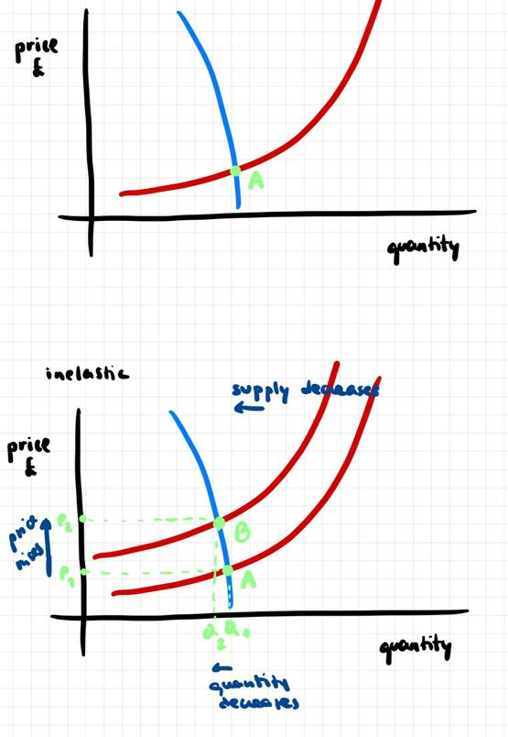
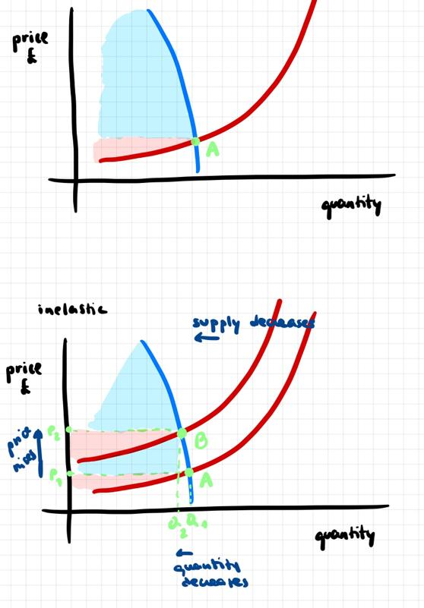

Supply(supply)-demand(blue) curves

Modelling agriculture (competitive)

Assumptions
- Agriculture is a perfectly competitive market. Buyers and sellers are price-takers. Sellers don’t decide the price, (they do decide the quantity produced) it’s the interaction of supply and demand that stablishes the price (market equilibrium).
- Vegetables, fruits, and more are identical goods, they don’t differ from one to another seller (though in practice can differ a little bit from one producer to another).
- We are considering agriculture products to be an elastic good. That’s because if we went to the store and we saw that apples are experiencing a higher price than usual, we would choose to grab another fruit (easy to replace). We can consider that domestic products (that are not imported or don’t use imported machines) are not affected by the sanction, for that reason their price will not affect, and consumers will change to that product.

Discussion:
We want to study the changes in price and quantities traded in a competitive market. The event that caused this change is a sanction that prohibit the import of modern technology. This caused the country to move from technology A to technology B. As we have seen, the technology A (before) is more effective than B (after). Let’s suppose that we are measuring the price of apples (any vegetable fruit would be similar). If we have a technology less efficient that produces apples, this will lead to a lower supply. The decrease in supply creates an excess demand at the initial price. Excess demand causes the price to rise, and quantity demanded to decrease. In other words, a decrease in supply will cause an increase in the equilibrium price and a decrease in the equilibrium quantity of a good.

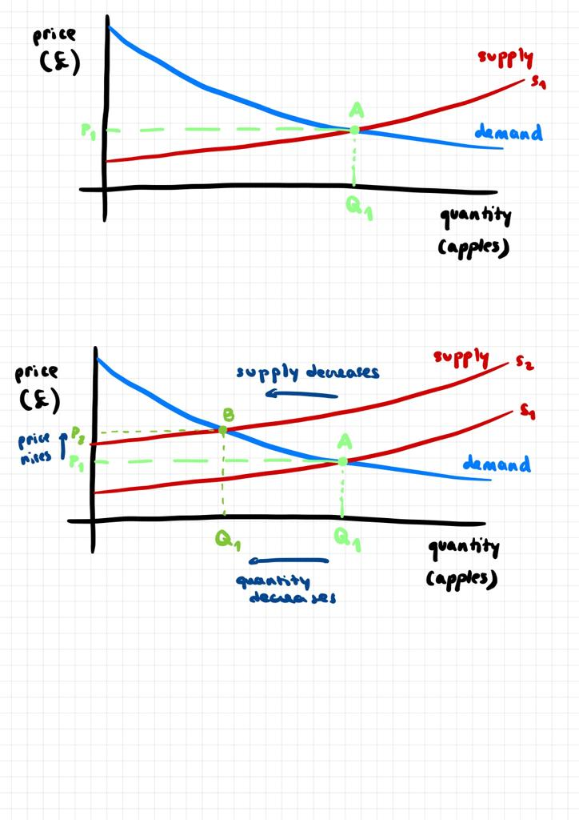
Before the sanction, the market is in competitive equilibrium.
A = (Q_1,P_1)

There is a new equilibrium at point B with a price of P2, at which Q2 apples are sold. (P2>P1, Q2<Q1).
The decrease in supply has led to a rise in the equilibrium price.

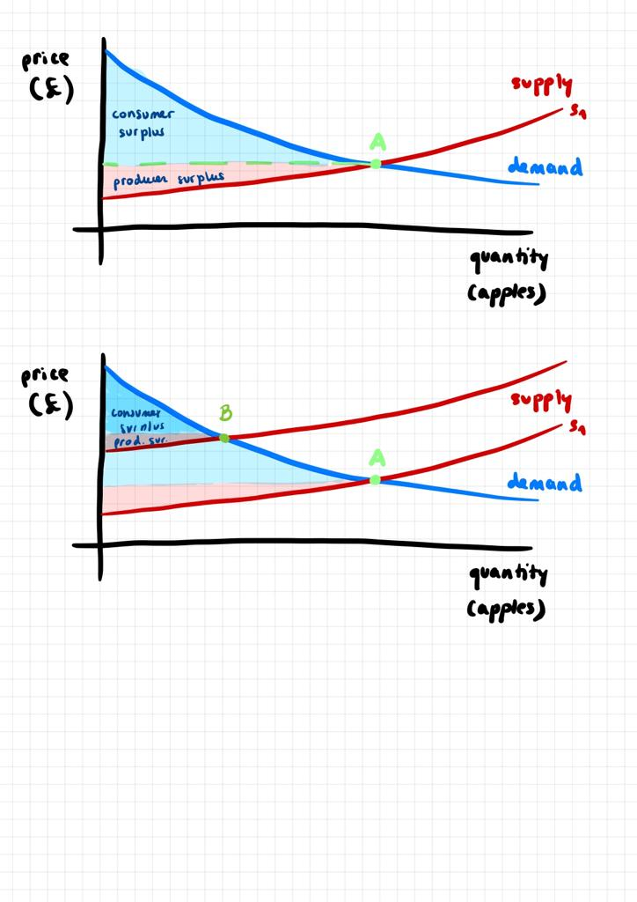

s

Sanctions causes supply to decrease, and we see a total economic surplus loss, both consumer and producer. Because there’s a lot of competition in the agriculture market, the ones that are less affected by the sanctions will benefit the situation and have more consumers. The ones that are affected by the sanction will have to adapt to the market price. The consumers would not notice that big of a difference.

Sanctions directly impact markets in the short term. When trade flows are restricted by sanctions, the foreign market is no longer competitive with the domestic one. This benefits the local producer creating rents.

Government would have to subside the producers that use foreign machines and goods because they will experience higher costs. Or they would have to tax the ones that don’t rely as much with external help.

